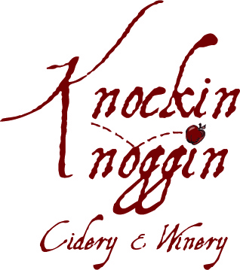
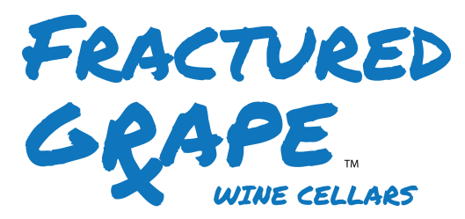
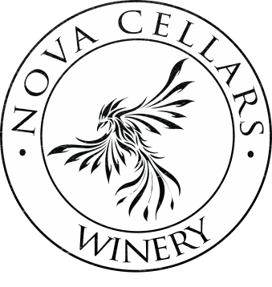
Application Questionnaire

Name a winery you admire and why? (It does not need to be one of ours)

Describe in detail the capabilities that you bring to this job.

What motivates you in life and work?

Describe your most memorable wine/winery experience.

Why do you want to work here and why should we hire you?

